**Appendix A: Submission Checklist**

Public GIT (Github/Bitbucket/Gitlab) url: [SpagnolLuca/Database_Assignment](https://github.com/SpagnolLuca/Database_Assignment)

Task 1 Screenshot of your development environment setup: 

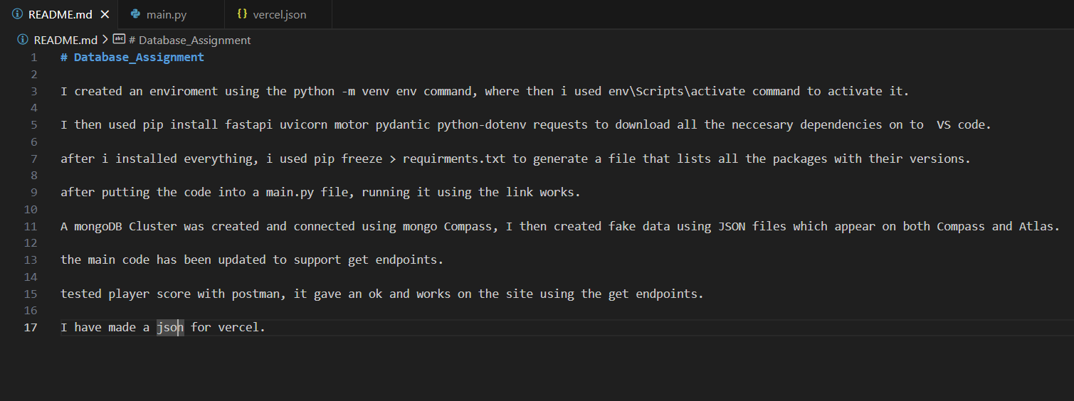

Task 2: Screenshot/s of your Mongo Database on MongoAtlas:

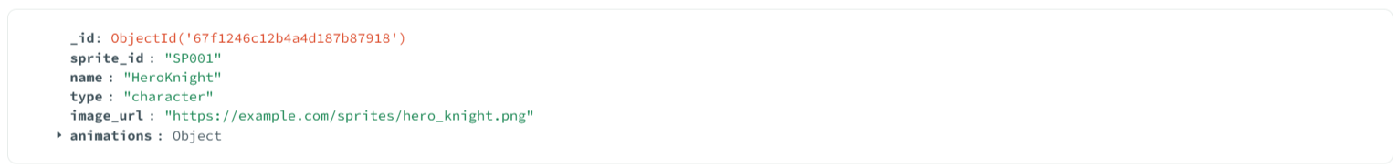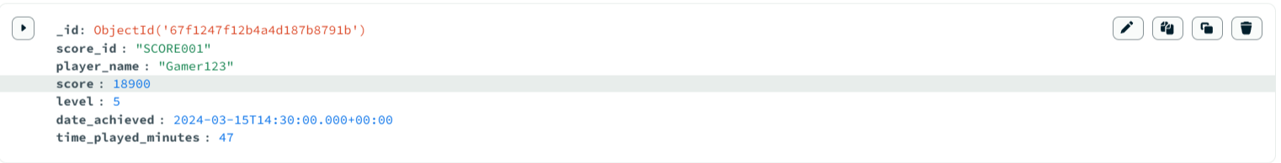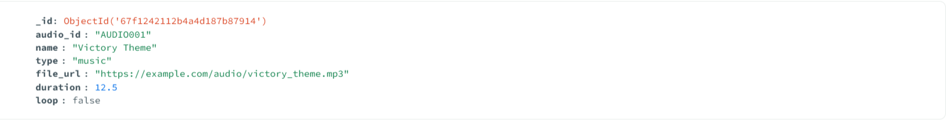

Task 3A: Screenshot of the API running on localhost in your browser:

Task 4A: Screenshot showing credential setup:

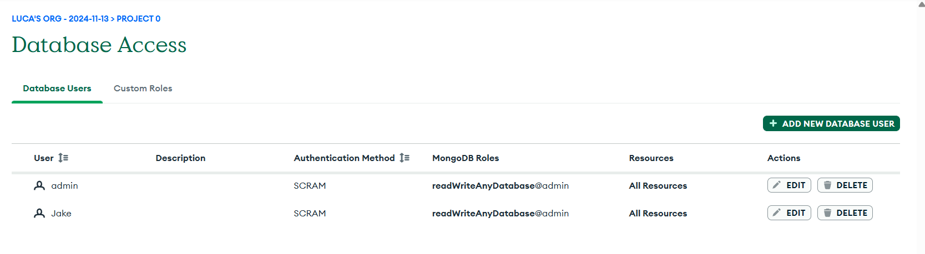

Task 4B: Screenshot showing IP whitelisting.

